Please put the images and text information of different categories in different folder. It would be great if you can give us a map listing out all the category names (see red boxes below).

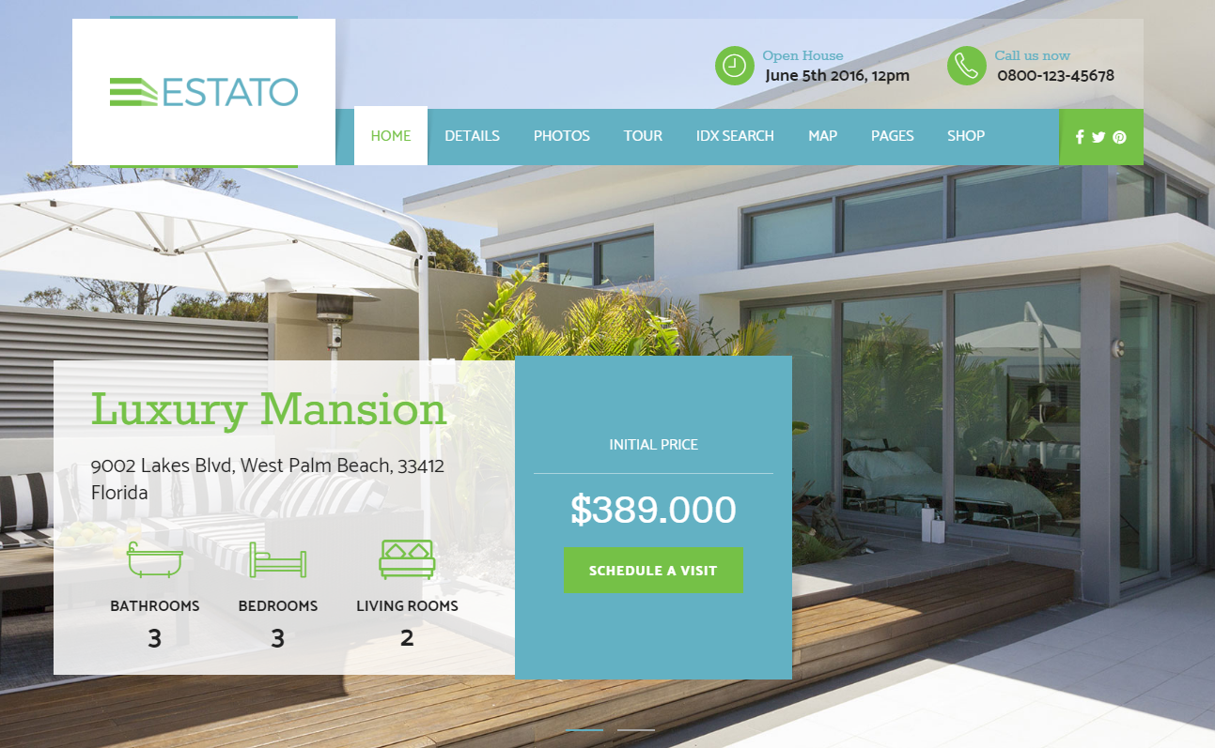

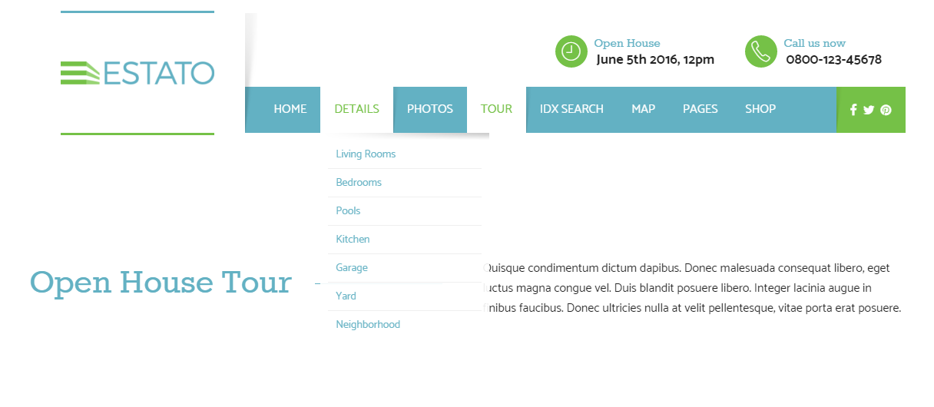

Please note that the images should be at least 72 dpi.

For texts, you may simply enter the texts in the tables or create a text file separately.

Should you have any enquiries, please feel free to contact us.

Thank you very much.

Homepage

Contact

Company Name and Logo

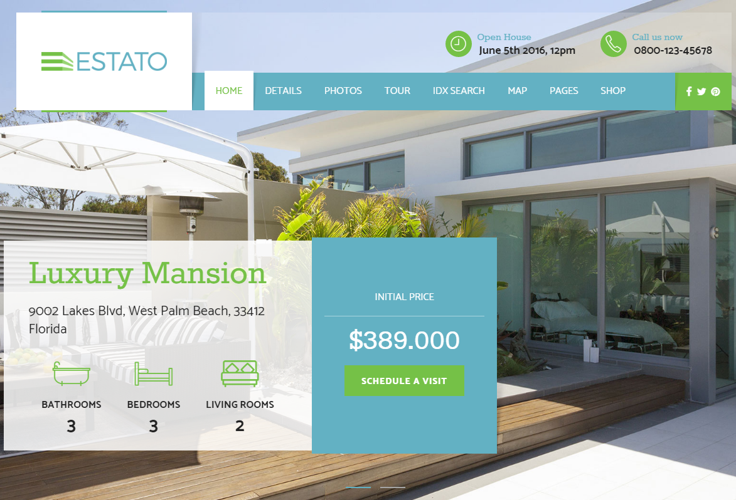

Information

Home slider

Social Networking links

Categories

|  |  |  |
| --- | --- | --- |
| **Text/Information** | **Characters (punctuation & space inclusive)** | **No. of items (at most)** |
| Company Name and Logo | At most 10 | 1 |
| Contact (Phone number) | At most 25 | 1 |
| Categories | At most 10 | 8 |
| Social networking links | Facebook:  Twitter:  Instagram: | 3 |
| Information | At most 150 | 1 |

|  |  |  |
| --- | --- | --- |
| **Images** | **Size** | **No. of images (At most)** |
| Home Slider | 2854.5 x 871.99 | 2 |

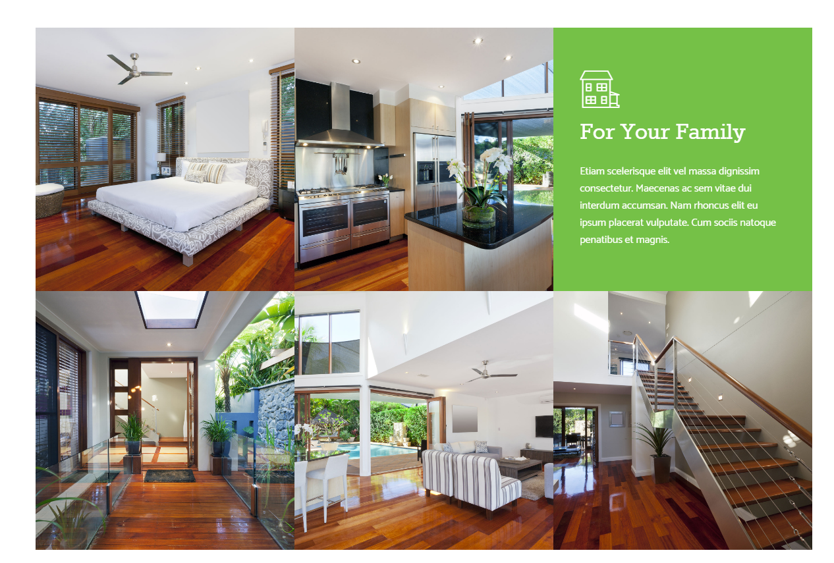

Image

Title and description

|  |  |  |
| --- | --- | --- |
| **Text/Information** | **Characters (punctuation & space inclusive)** | **No. of items (at most)** |
| Title and description | At most 200 | 1 |

|  |  |  |
| --- | --- | --- |
| **Images** | **Size** | **No. of images (At most)** |
| Image | 393.31 x 393.31 | 5 |

Image

Text

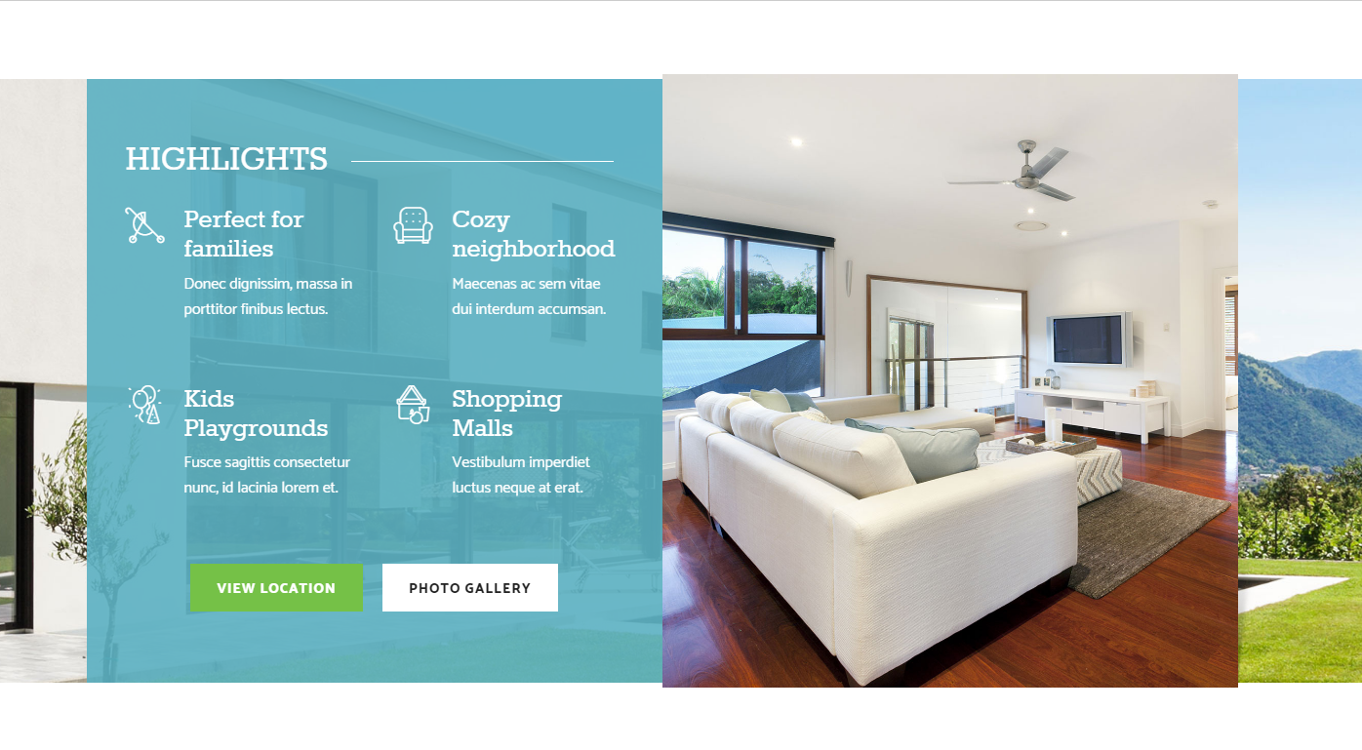

|  |  |  |
| --- | --- | --- |
| **Text/Information** | **Characters (punctuation & space inclusive)** | **No. of items (at most)** |
| Text | At most 250 | 1 |

|  |  |  |
| --- | --- | --- |
| **Images** | **Size** | **No. of images (At most)** |
| Image | 589.99 x 739.97 | 2 |

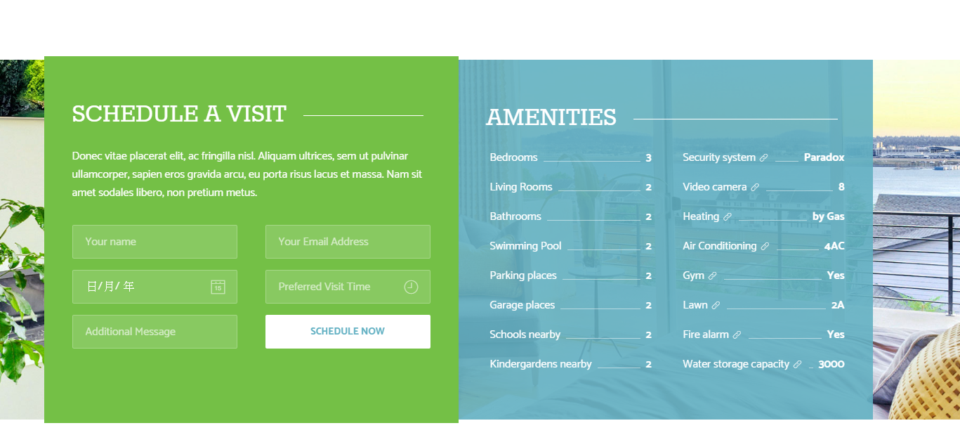

Background image

Appointment

Text

|  |  |  |
| --- | --- | --- |
| **Text/Information** | **Characters (punctuation & space inclusive)** | **No. of items (at most)** |
| Appointment | At most 215 | 1 |
| Text | At most 300 | 1 |

|  |  |  |
| --- | --- | --- |
| **Images** | **Size** | **No. of images (At most)** |
| Background image | 1960.5 x 568.36 | 1 |

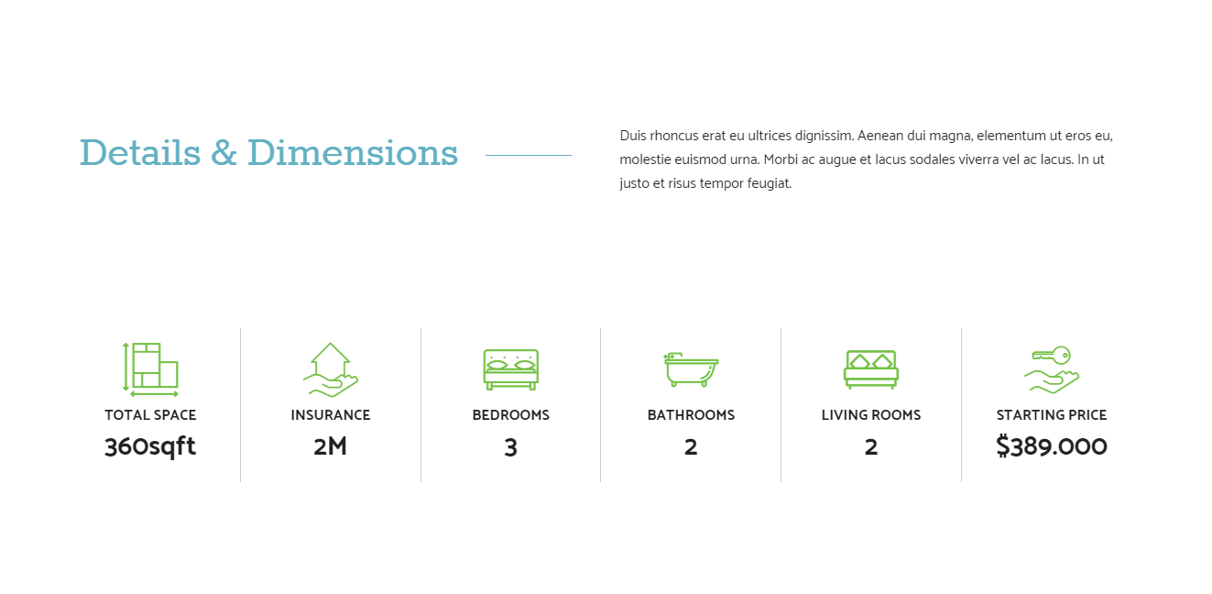

Title

Description

Information

icon

|  |  |  |
| --- | --- | --- |
| **Text/Information** | **Characters (punctuation & space inclusive)** | **No. of items (at most)** |
| Title | At most 20 | 1 |
| Description | At most 200 | 1 |
| Information | At most 25 | 6 |

|  |  |  |
| --- | --- | --- |
| **Images** | **Size** | **No. of images (At most)** |
| Icon | 156.66 x 60 | 6 |

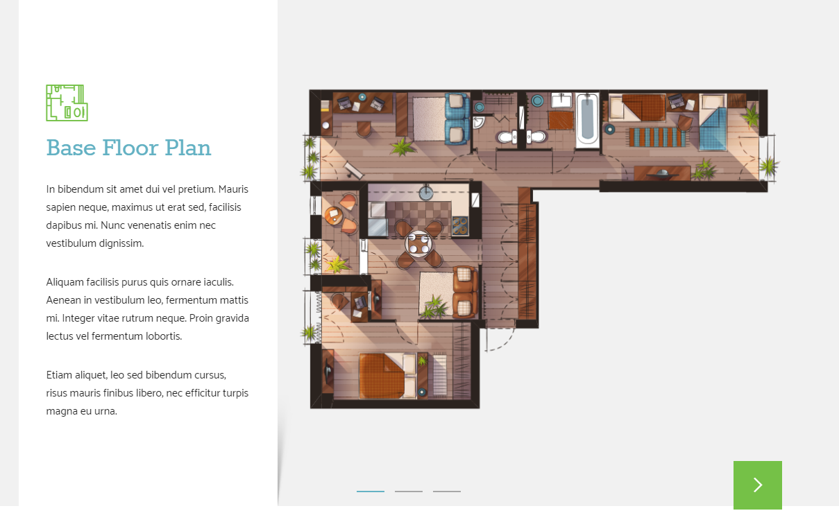

Image

Description

Title

|  |  |  |
| --- | --- | --- |
| **Text/Information** | **Characters (punctuation & space inclusive)** | **No. of items (at most)** |
| Title | At most 20 | 3 |
| Description | At most 450 | 3 |

|  |  |  |
| --- | --- | --- |
| **Images** | **Size** | **No. of images (At most)** |
| Image | 706.66 x 825 | 3 |

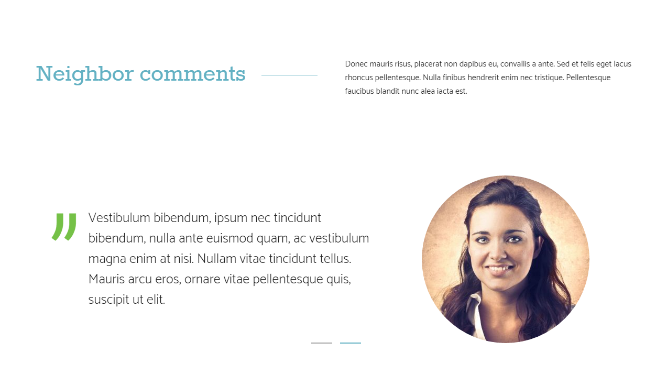

Image

Comments

Title

Description

|  |  |  |
| --- | --- | --- |
| **Text/Information** | **Characters (punctuation & space inclusive)** | **No. of items (at most)** |
| Title | At most 20 | 2 |
| Description | At most 450 | 2 |
| Comments | At most 210 | 2 |

|  |  |  |
| --- | --- | --- |
| **Images** | **Size** | **No. of images (At most)** |
| Image | 320 x 320 | 2 |

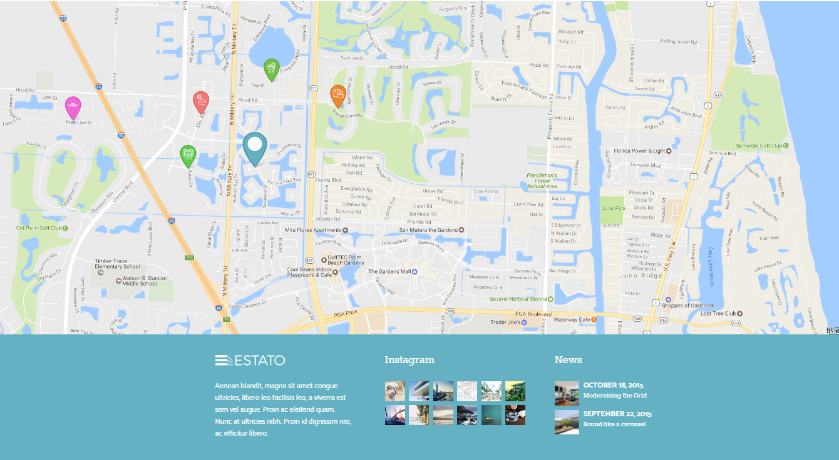

Category

Text

Image

Company Info

Google Map

|  |  |  |
| --- | --- | --- |
| **Text/Information** | **Characters (punctuation & space inclusive)** | **No. of items (at most)** |
| Company Info | At most 200 | 1 |
| Category | At most 10 | 2 |
| Text | At most 40 | 2 |
| Google Map location | / | 1 |

|  |  |  |
| --- | --- | --- |
| **Images** | **Size** | **No. of images (At most)** |
| Image | 47.75 x 47.75  59 x 59 | 10 |

Photo page

Description

Category Name

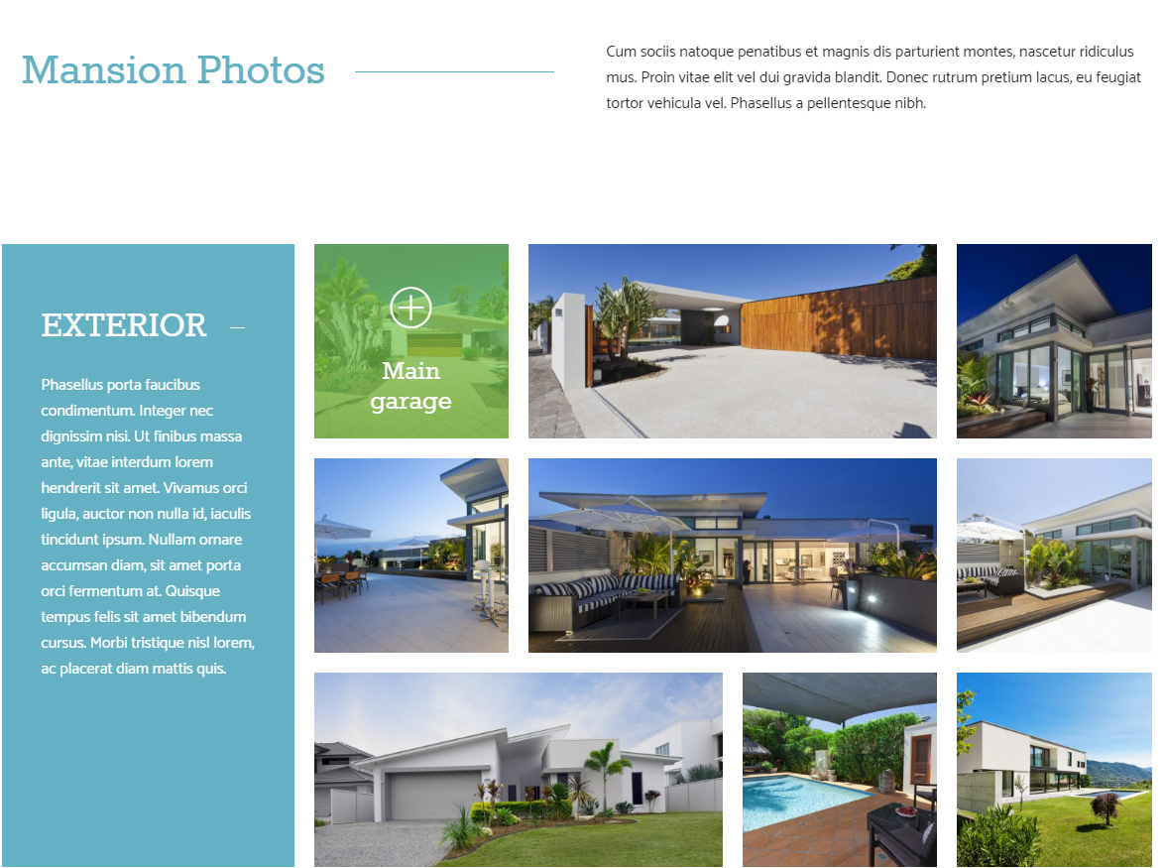

Image with fade-in description

Title

and

Description

|  |  |  |
| --- | --- | --- |
| **Text/Information** | **Characters (punctuation & space inclusive)** | **No. of items (at most)** |
| Category Name | At most 15 | 1 |
| Description | At most 250 | 1 |
| Text and Description | At most 350 | 2 |

|  |  |  |
| --- | --- | --- |
| **Images** | **Size** | **No. of images (at most)** |
| Image with fade-in description | 300 x 300  600 x 300 | 9 |